**Bacterial Toxins’ Seq Protocols**

There are two ways to label the antigen protein, using AviTag or Flag-M2-tag/His-tag tagging method.

1. **AviTag**
2. **Antigen expression and purification**
3. Bacterial Toxins’ cDNA is fused with AviTag at the C terminal using modified inverse PCR mutagenesis protocol as described by Fairhead M.2

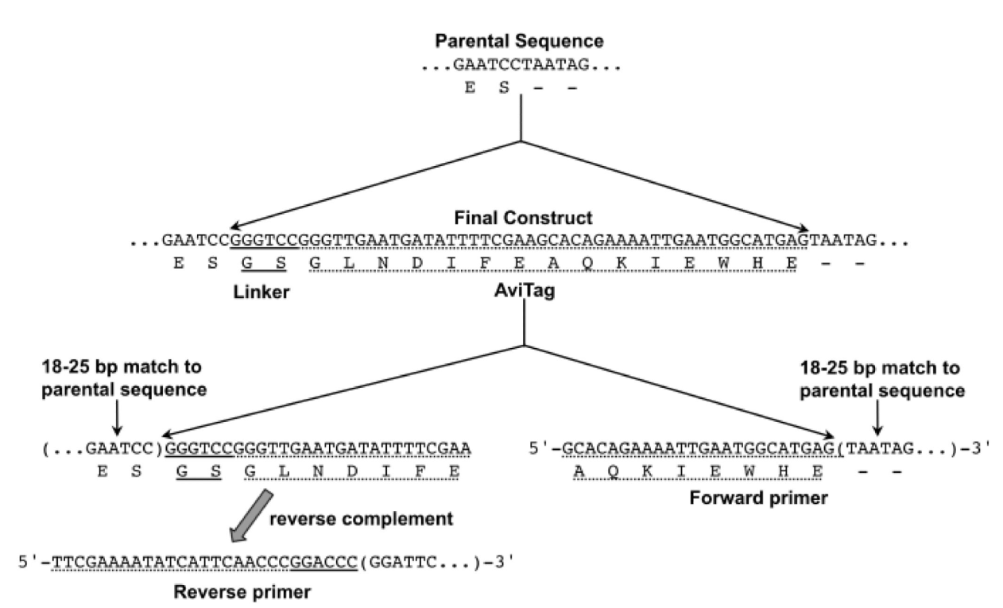

**Figure 1.** Schematic of AviTag sequence insertion by inverse PCR

1. After validating the construct by sequencing, the AviTag-fused protein can be overexpressed in the appropriate mammalian expression system (e.g. 293F cells).
2. The expressed protein then purified to remove unwanted molecules (e.g. molecular weight filtration column).
3. Biotinylation of Avitag labeled antigen using BirA-5002
   * 1. magnesium chloride, ATP, BirA-500 and D-Biotin is added to AviTag-fused protein in PBS
     2. Incubate the sample with gentle mixing according to manual instruction of the biotinylation kit
     3. Add the same amount of fresh biotin and GST-BirA and incubate
     4. Remove the BirA-500 by incubating the sample with 50% slurry of glutathione-HiCap resin in PBS for 30 minutes at room temperature, followed by centrifugation and collection of the supernatant
     5. Filtrate the supernatant with molecular weight filtration column to remove the excess biotin
4. **(Optional) Conjugation of oligonucleotide (DNA Barcode) to antigen protein using Solulink Protein-Oligonucleotide Conjugation Kit (TriLink cat no. S-9011)3**

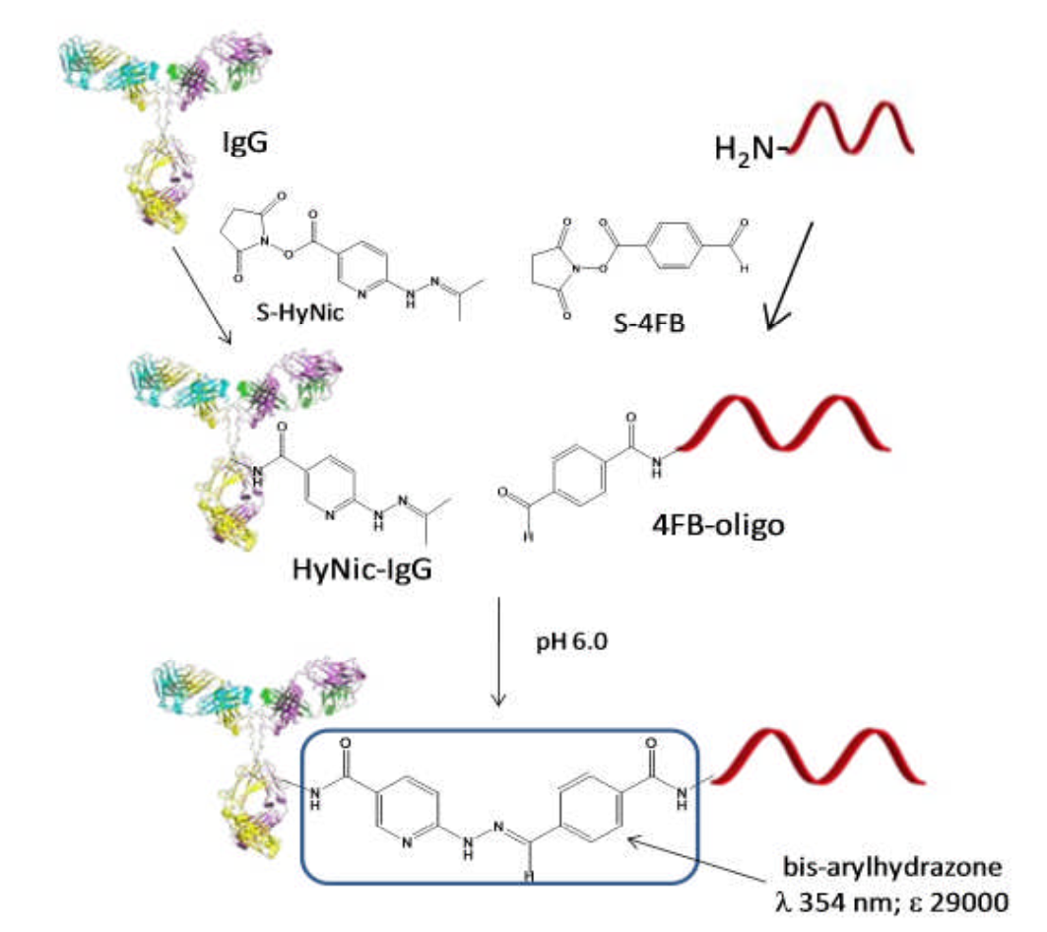

**Figure 2.** Schematic of protein barcoding by Solulink (depicted here is IgG)

* 1. The biotinylated protein is then barcoded by DNA (one DNA barcode for one type of protein). The procedure as follows.
  2. Desalt the antigen protein and oligonucleotide using ZebaTM Desalt Spin Columns
     1. Preparation
        1. Remove spin column’s bottom closure and loosen the top cap
        2. Place spin column in 2.0 ml microcentrifuge collection tube
        3. Centrifuge at 1,500 x g for 1 minute to remove storage solution
        4. Place a mark on the side of the column where the compacted resin is slanted upward
        5. Add 300 µl of required buffer to the top of the resin bed and centrifuge at 1,500 x g for 1 minute, discarding the flow-through from the collection tube
        6. Repeat step 5 two additional times, discarding buffer from the collection tube
        7. The column is now ready for sample loading
     2. Sample Loading
        1. Place column in a new 2.0 ml microcentrifuge tube, remove the cap and slowly apply 50-130 µl of sample to the center of the compacted resin bed
        2. Centrifuge column at 1,500 x g for 2 minutes to collect the desalted sample
        3. Discard column after use
        4. Confirm protein or oligo concentration and now ready for the next step
  3. Oligonucleotide modification with S-4FB
     1. Enter oligonucleotide information into conjugation calculator
     2. Resuspend the oligonucleotide
     3. Measure the oligonucleotide concentration using a spectrophotometer
     4. Buffer exchange
     5. Dissolve S-4FB reagent
     6. Modify oligonucleotide with S-4FB reagent
     7. Removal of excess S-4FB
     8. Measure the 4FB-oligonucleotide concentration
     9. Quantify 4FB molar substitution ratio
  4. Antigen protein modification with S-HyNic
     1. Enter the antigen protein information into S-HyNic Modification Calculator
     2. Add the required volume of anhydrous DMF to a 0.5 mg vial of pre-weighed S-HyNic reagent
     3. Pipette the solution up and down to dissolve the pellet
     4. If protein molecular weight is greater than 50,000 Daltons, add 2.0 µl of S-HyNic reagent to the desalted protein.
     5. If protein molecular weight is equal or less than 50,000 Daltons, add 3.0 µl of S-HyNic reagent
     6. Vortex to mix
     7. Incubate at room temperature for 2.5 hours
     8. Proceed to desalt the HyNic-modified protein using 0.5 ml ZebaTM Column equilibrated with 1x conjugation buffer
  5. 4FB-oligonucleotide - HyNic-protein conjugation protocol
     1. Input the 4FB-oligonucleotide and HyNic-protein information into the conjugation calculator. It will determine the volumes of 4FB-oligonucleotide, HyNic-protein, and 10X TurboLink Catalyst Buffer required to add into the conjugation solution
     2. Incubate at room temperature for 2-3 hours or 40C for overnight
     3. The conjugation reaction is now ready for purification by column chromatography or desalting into storage buffer
     4. Determine final protein concentration using BCA or Bradford assay
     5. Add bacteriostat and/or protein stabilizer if necessary, then store at 40C

1. **Fluorescent labeling of antigen**
   1. Mix the barcoded antigen with streptavidin labeled with fluorophore phycoerythrin (PE)
   2. The streptavidin-PE was mixed with barcoded antigen at 5x molar excess of antigen to streptavidin
   3. ⅕ of the streptavidin-oligo conjugate was added to the antigen every 20 minutes with constant rotation at 40C
2. **Enrichment of antigen-specific B cells**
   1. B cells from vaccinated subject’s blood are sort using fluorescence-activated cell sorting (FACS) or magnetic-activated cell sorting (MACS)
   2. Mix the fluorescently-labeled DNA-barcoded antigens with B cells.
   3. Sort using FACS
      1. Using Trypan Blue, we count the cells and assess the viability
      2. Wash the cells with RPMI supplemented with 1% Bovine Serum Albumin (BSA) through centrifugation at 300 g for 7 minutes
      3. Resuspend the cell in PBS-BSA and stain with a variety of cell markers
      4. Additionally, fluorescently labeled antigen-oligo conjugates were added to the stain
      5. Stain in the dark for 30 minutes at room temperature
      6. Wash the cells 3 times using PBS-BSA at 300 g for 7 minutes
      7. Resuspend in RPMI and sort on the cell sorter
      8. Antigen positive cells are bulk sorted, 10X Genomics library preparation and subsequent sequencing
      9. FACS data then analyzed.

**B. Flag-M2-tag/His-tag**

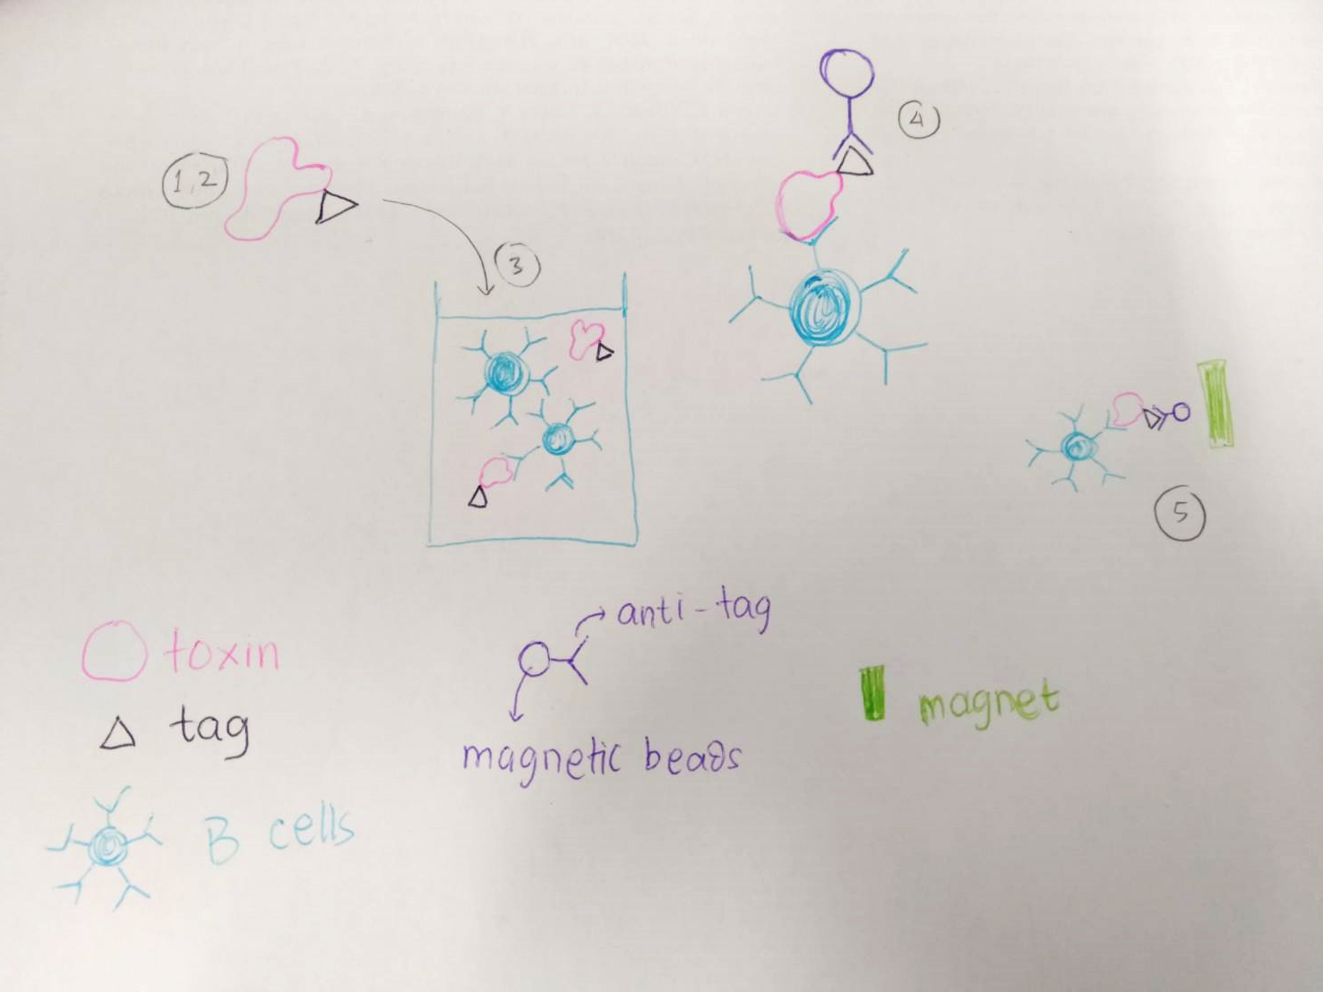

**Figure 3.** Ilustration of B cell sorting using Flag-M2-tag/His-tag and magnetic beads

1. Bacterial toxin cDNA is fused by the Flag-M2-tag/His-tag. Fused DNA then ligated to expression plasmids and expressed in an appropriate expression system (e.g. *E.coli*).
2. The expressed toxins then purified.
3. Mix the tag labeled toxin with B cells taken from immunized individuals.
4. Add magnetic beads and incubate for 15 minutes on ice.
5. Catch the B cell attached with antigen using magnetic kits (MACS).

**10X Genomics single-cell processing and NGS**

* 1. Single-cell suspensions were loaded onto the Chromium Controller microfluidics device (10X Genomics) and processed using the B cell Single Cell V(D)J solution according to manufacturer’s suggestions
  2. Library preparation following the CITE-seq protocol (available at <https://cite-seq.com>)

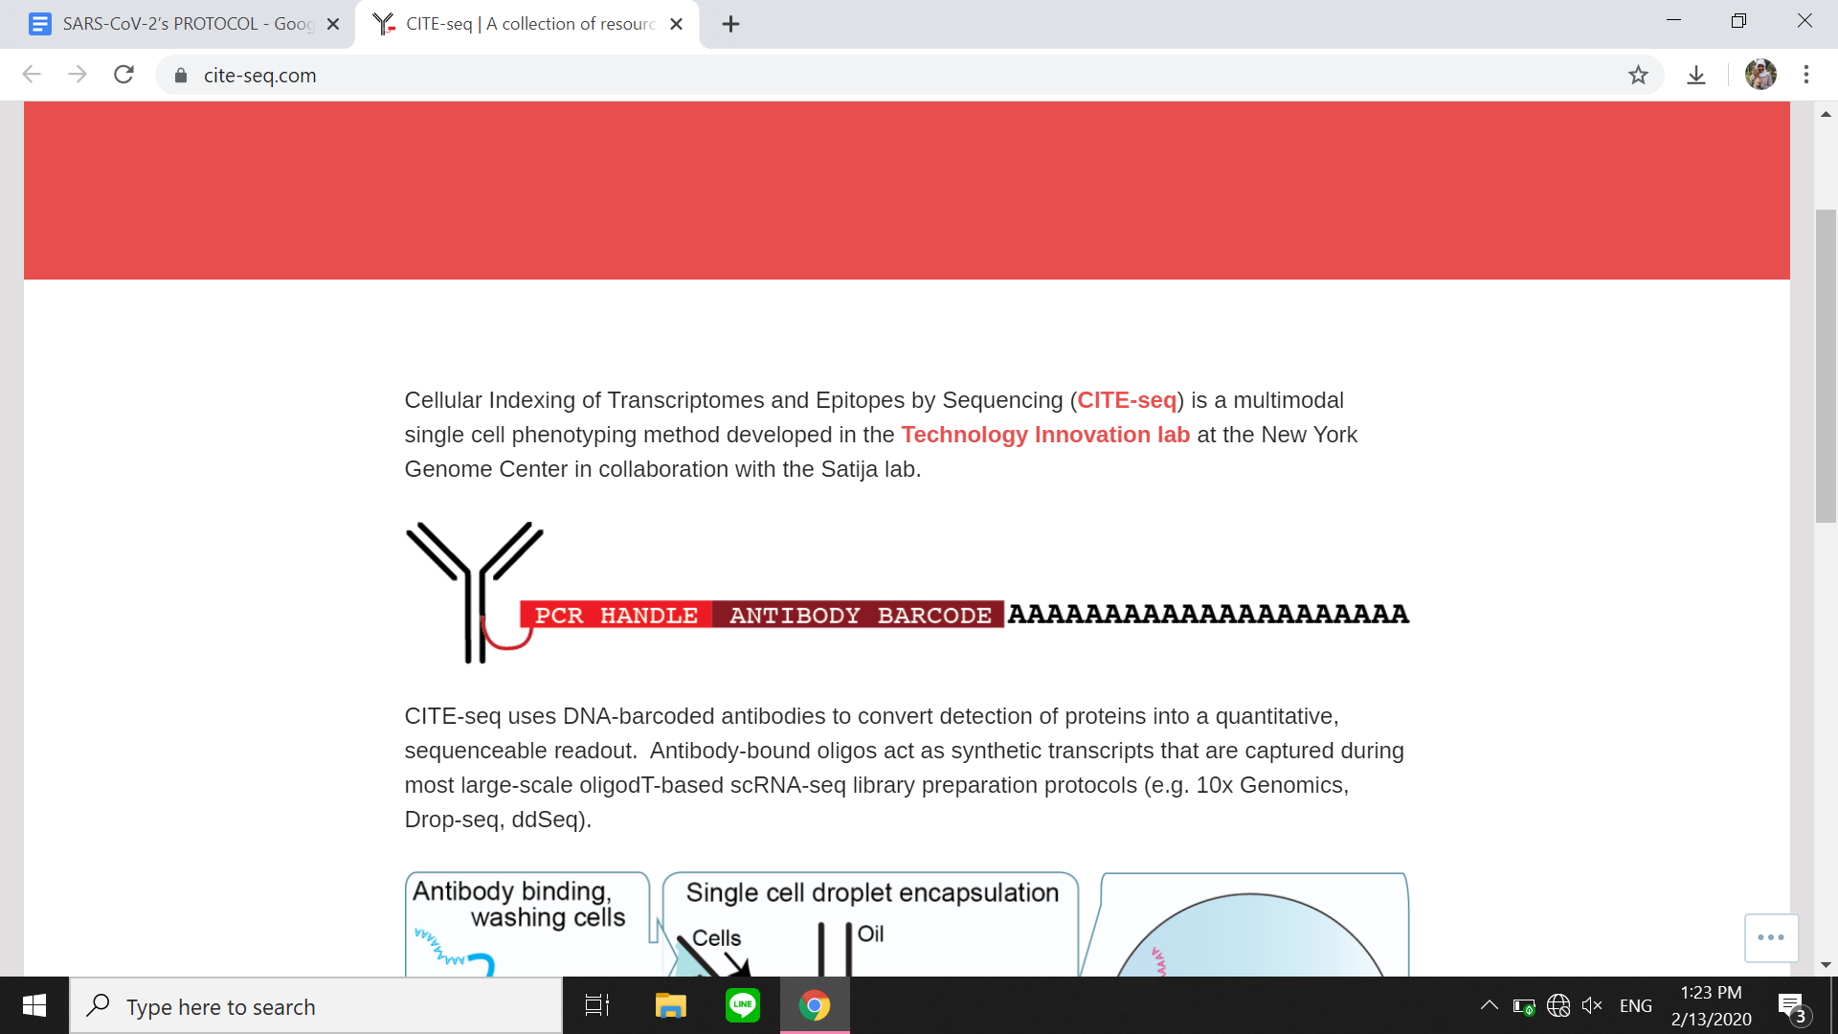

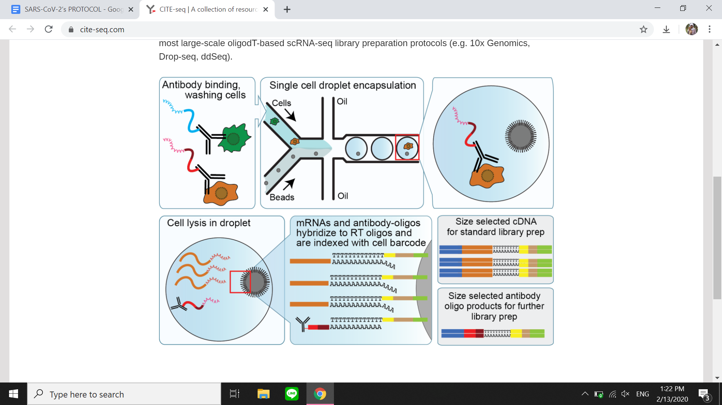

**Figure 4.** Schematic of 10X Genomics single-cell sequencing

* + 1. cDNA amplification using an additive primer (5’CCTTGGCACCCGAGAATT*C*C-3’)
    2. SPRI separation
    3. PCR amplified for 10-12 cycles
    4. Purified using 1.6X purification
    5. Sample preparation for the cellular mRNA library according to 10X Genomics-suggested protocols, resulting in Illumina-ready libraries
  1. Sequence both BCR and antigen barcode libraries on appropriate NGS machine

**References**

1. Setlif I, Andrea RS, Kelsey AP, Amyn AM, Rutendo EM, Katarzyna J, Simone R, Charissa O, Nagarajan R, Larance R, Masaru K, Juliana SQ, Kevin JK, Allison RG, Wyatt JM, Barney SG, Mark C, Daniel L, Priyama A, Lynn M, Ivelin SG. High-throughput mapping of B cell receptor sequences to antigen specificity. *Cell* 2019; 179:1636-1646.
2. Fairhead M, Howarth M. Site-specific biotinylation of purified proteins using BirA. *Methods Mol Biol.* 2015; 1266: 171-184.
3. SoluLink Protein-Oligonucleotide Conjugation Kit Technical Manual. 2013.